Choice F:
Two-way set associative with Total cache size = 6 words, Block size = 1 words

- An explanation of what the cache looks like, including how many cache indexes or sets there will be.
- An explanation of how the following 20 memory words will be mapped to the cache, if they are accessed in the order listed:
30, 31, 32, 33, 30, 31, 34, 35, 40, 41, 32, 30, 40, 41, 50, 43, 44, 40, 41, 43
- For each word access above, indicate:
  - what memory block the word belongs to
  - what cache index or cache set the memory block will be mapped to
  - whether the result is a hit or a miss
  - if it is a miss, which memory words will be loaded into the cache and what words will be overwritten (if any), using the LRU replacement algorithm
- Show the final cache contents after all words have been accessed.
- Give the cache hit rate for these 20 words.
Note: You may find it easiest to do this in an Excel spreadsheet, and then just attach the spreadsheet file to your reply.
Everyone should choose a DIFFERENT cache organization/size combination from the list above.
- Include the LETTER of your choice in your subject line, so everyone can tell what has already been covered.
Hint: You can post your letter choice early, to reserve it, then come back to finish up the example later.

6 words DIV 2 = 3 cache sets (with 2 lines each)

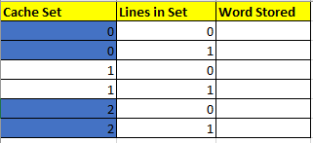

Mapping:
30 MOD 3 = 0
- Search for memory 30 in set 0
- MISS - Memory word 30 is not in cache set 0
- Load word 30 into first empty line in cache set 0, (set 0, line 0)
31 MOD 3 = 1
- Search for memory 31 in set 1
- MISS - Memory word 31 is not in cache set 1
- Load word 31 into first empty line in cache set 1, (set 1, line 0)
33 MOD 3 = 0
- Search for memory 33 in set 0
- MISS - Memory word 33 is not in cache set 0
- Load word 33 into first empty line in cache set 0, (set 0, line 1)
- Swap line 0 of cache set 0 with line 1 of cache set 0 (LRU algorithm)
30 MOD 3 = 0
- Search for memory 30 in set 0
- HIT- Memory word 30 is in line 0 of cache set 0
- Swap line 0 of cache set 0 with line 1 of cache set 0 (LRU algorithm)
31 MOD 3 = 1
- Search for memory 31 in set 1
- HIT- Memory word 31 is in line 0 of cache set 1
- Word 31 is already in the LRU position.
34 MOD 3 = 1
- Search for memory 34 in set 1
- MISS - Memory word 34 is not in cache set 1
- Load word 34 into first empty line in cache set 1, (set 1, line 0)
- Swap line 0 of cache set 1 with line 1 of cache set 1 (LRU algorithm)
35 MOD 3 = 2
- Search for memory 35 in set 2
- MISS - Memory word 35 is not in cache set 2
- Load word 35 into first empty line in cache set 2, (set 2, line 0)
40 MOD 3 = 1
- Search for memory 40 in set 1
- MISS - Memory word 40 is not in cache set 1
- Load word 40 into line 1 in cache set 1 and reject word 31 (LRU algorithm)
- Swap line 0 of cache set 1 with line 1 of cache set 1 (LRU algorithm)
41 MOD 3 = 2
- Search for memory 41 in set 2
- MISS - Memory word 41 is not in cache set 2
- Load word 41 into first empty line in cache set 2, (set 2, line 1)
- Swap line 0 of cache set 1 with line 1 of cache set 1 (LRU algorithm)
32 MOD 3 = 2
- Search for memory 32 in set 2
- MISS - Memory word 32 is not in cache set 2
- Load word 32 into line 1 in cache set 2 and reject word 35 (LRU algorithm)
- Swap line 0 of cache set 2 with line 1 of cache set 2 (LRU algorithm)
30 MOD 3 = 0
- Search for memory 30 in set 0
- HIT- Memory word 30 is in line 0 of cache set 0
- Word 30 is already in the LRU position.
40 MOD 3 = 1
- Search for memory 40 in set 1
- HIT- Memory word 40 is in line 0 of cache set 1
- Word 40 is already in the LRU position.
41 MOD 3 = 2
- Search for memory 41 in set 2
- HIT- Memory word 41 is in line 1 cache set 2
- Swap line 0 of cache set 2 with line 1 of cache set 2 (LRU algorithm)
50 MOD 3 = 2
- Search for memory 50 in set 2
- MISS - Memory word 50 is not in cache set 2
- Load word 50 into line 1 in cache set 2 and reject word 32 (LRU algorithm)
- Swap line 0 of cache set 2 with line 1 of cache set 2 (LRU algorithm)
43 MOD 3 = 1
- Search for memory 43 in set 1
- MISS - Memory word 43 is not in cache set 1
- Load word 43 into line 1 in cache set 1 and reject word 34 (LRU algorithm)
- Swap line 0 of cache set 1 with line 1 of cache set 1 (LRU algorithm)
44 MOD 3 = 2
- Search for memory 44 in set 2
- MISS - Memory word 44 is not in cache set 2
- Load word 44 into line 1 in cache set 2 and reject word 41 (LRU algorithm)
- Swap line 0 of cache set 2 with line 1 of cache set 2 (LRU algorithm)
40 MOD 3 = 1
- Search for memory 40 in set 1
- HIT- Memory word 40 is in line 1 cache set 1
- Swap line 0 of cache set 1 with line 1 of cache set 1 (LRU algorithm)
41 MOD 3 = 2
- Search for memory 41 in set 2
- MISS - Memory word 41 is not in cache set 2
- Load word 41 into line 1 in cache set 2 and reject word 50 (LRU algorithm)
- Swap line 0 of cache set 2 with line 1 of cache set 2 (LRU algorithm)
43 MOD 3 = 1
- Search for memory 43 in set 1
- HIT - Memory word 43 is in line 1, cache set 1
- Swap line 0 of cache set 1 with line 1 of cache set 1 (LRU algorithm)

After all 20 memory accesses, the cache would contain:

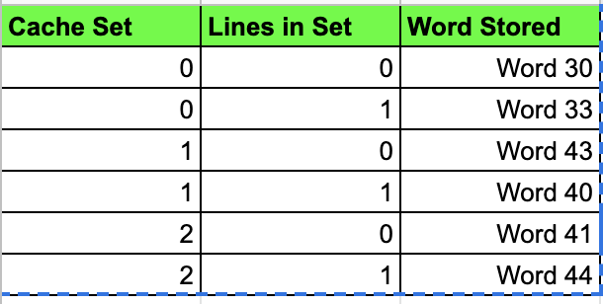

Hit Rate = 7/20 = 35%

